# SCHOOL OF COMPUTING SCIENCE AND DIGITAL MEDIA

# CMM007 - Intranet System Development

|  |
| --- |
| Student Name: Baz Khil |
| Student Number: 1709517 |

## 1.0 Web Application

This application is the supply to the demand for a research paper sharing application. The research paper sharing application will have the ability to upload papers, allocate papers, store papers, review papers, monitor and track papers, and to share project papers among a group of people. Due to the demand for such an application, an application which satisfies the need will be delivered in this project.

The application will have 3 user roles:

|  |
| --- |
| Administrator |
| Team Leader |
| Student |

In order to be one of the above users, the user must be registered first. Furthermore, the user must be logged in to perform actions that are mentioned above such as reviewing, uploading, monitoring etc.

Administrators will be able to set up projects and allocate students and giving one of the students the role of a team leader within a project. the Team Leader will be able to perform actions after an administrator has sent them a **personalized link** and Team Leaders are only able to allocate papers to students for review. Moreover, students will only be able to upload research papers, see the papers that they have been allocated to and review them and also upload their reviews. Students will also be able to view all papers and reviews but only with a personalized link after the student has logged in.

## 2.0 Constraint

### **2.1 The research paper application will be hosted on a webserver.**

1. The whole project will be hosted on the university’s webserver which is web-dev/ MYPHPADMIN.

### **2.2 The project will also have an up to date code committed to GitHub.**

1. All of the code of this project will be made available on github.com/Bazionaire/

### **2.3 The application will have both front and back end code.**

1. Back End code of this project will exist of the logic and the data that performs the user’s requests. Whenever the user requests something, a query will run and respond to the user on the front end.
2. Front end code will exist of the code that the user interacts with to execute tasks on the platform. The front end will be composed of beautiful and user-friendly design which will not be complex to execute. Front end features and design will be done by using HTML and CSS and to perform the functionalities, PHP and MySQL will be used.

### **2.4 The research paper application will have the following features:**

1. Login system which allows you to gain access and log out.

Security Mechanism which allows authorized users to log in and prevent un-authorized to log in. in order to achieve this function. HTML, CSS, PHP and MySQL will be used.

1. More than one user role (*Authorization measure and Identity Management*)
   1. Administrator will be able to assign students with the role of a team leader. Furthermore, Administrators will be able to set up projects and allocate students to the project.
   2. The Team Leaders will be able to have the ability to allocate papers to students for review.
   3. Students will be able to get access through a link that has been sent by a Team leader.
2. File uploading system

This functionality will allow the users to upload and download research papers. This functionality will be achieved through using MySQL as a database which is then connected to PHP and HTML/CSS.

1. System to input data and then recall it from a database

MySQL will be used as a database which will store the user details such as their credentials for logging in and also the uploaded files. For recalling data from the database, PHP will be used.

## 3.0 Functional and Non-Functional Requirements

The following are the functional and non-functional requirements:

|  |  |  |
| --- | --- | --- |
| **Number** | **Functional Requirements** | **MOSCOW METHOD** |
| 1 | User friendly front-end interaction interface | Must Have |
| 2 | User-Friendly Login and Log Out functionality | Must Have |
| 3 | Different user roles: Administrator, Team Leader and Student. | Must Have |
| 4 | Administrator will have the ability to create projects | Must Have |
| 5 | Administrator will have the ability to assign team leaders and allocate students to projects. | Must Have |
| 6 | Team Leader will able to Upload papers and allocate students to projects for reviewing | Must have |
| 7 | Students should be able to enter the system through a personalized link. | Should have |
| 8 | Students will be able to upload research papers | Must Have |
| 9 | Students will be able to see any of the of the allocated papers and will be able to upload their reviews. | Must have |
| 10 | Students will be able to view all papers and reviews | Must Have |
| 11 | A database which stores projects, uploaded papers, student reviews, and comments made any of the user roles. | Should have |
| 12 | All the members within a project will be able to see comments and reviews among each other | Could have |
| 13 | System will have an authenticating system to allow users with authorized access to log in | Must have |
| 14 | Student being able to create projects | Won’t Have |
| 15 | Team Leader being able to create Projects | Won’t Have |

|  |  |  |
| --- | --- | --- |
| **Number** | **Non-Functional Requirements** | **MOSCOW METHOD** |
| 1 | All users will be allowed to use the system | Must have |
| 2 | Application will be easy to use and user-friendly | Must have |
| 3 | Use of the system and the application shall run smooth to ensure good user experience | Must have |
| 4 | Application will have a back-up and recovery procedure in case of an incident | Must have |
| 5 | Application will be compatible with all devices | Should have |
| 6 | The application will have enough storage to store all of the data that it collects | Must have |
| 7 | The data on the application shall be consistent, accurate and reliable. | Should Have |
| 8 | Privacy measurements will be taken to ensure that the confidentiality of all users is maintained. | Must Have |
| 9 | The server of the application will be running at all times to ensure that the application is available at any given time. | Must Have |
| 10 | The application will meet the needs of the users | Should have |

## 4.0 Wireframe and DataBase Designs

Figure DataBase Design

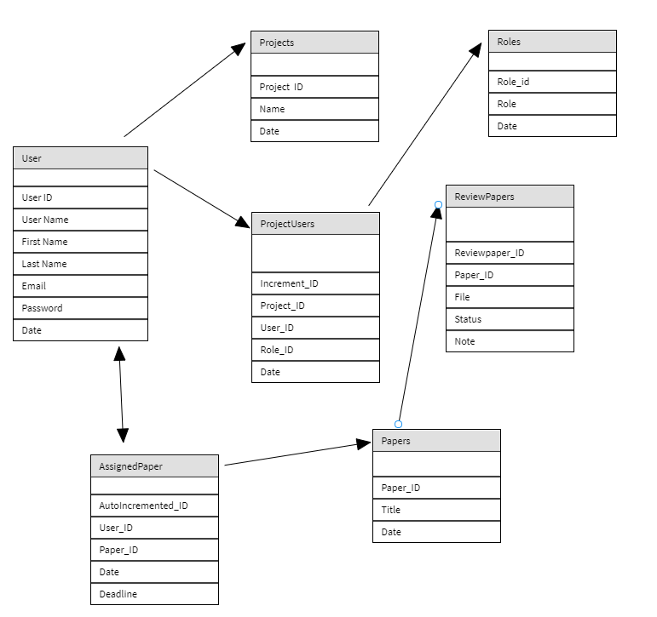

Figure Welcome Page and Log In Page

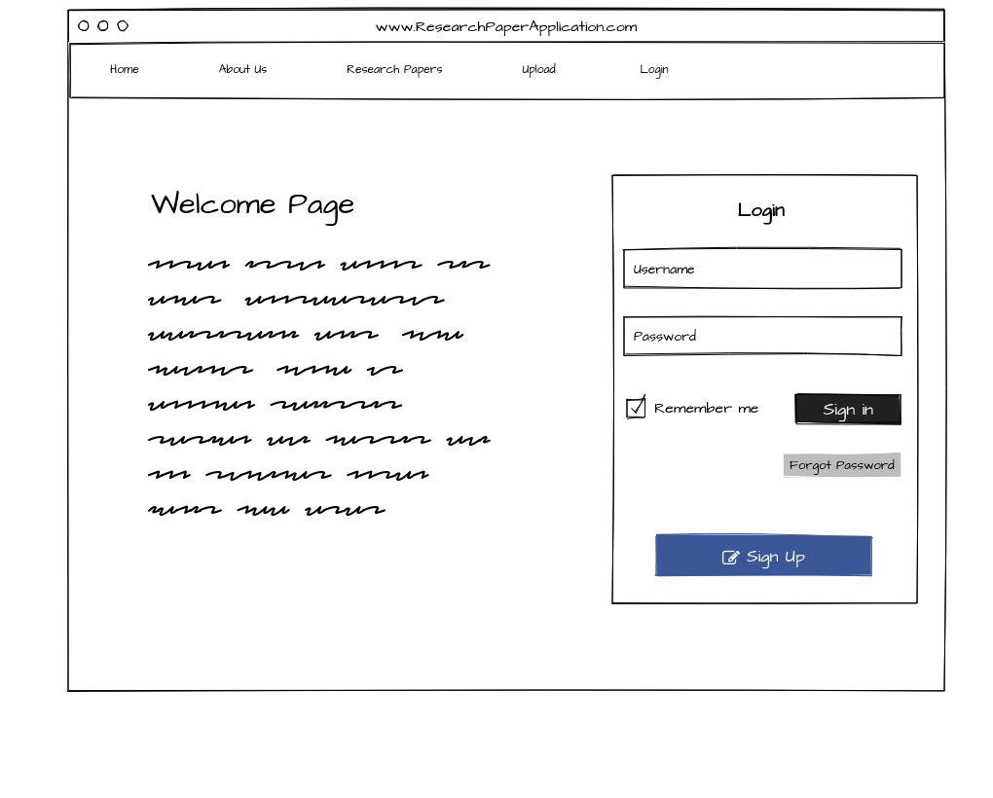

Figure Administrator: Create User Page

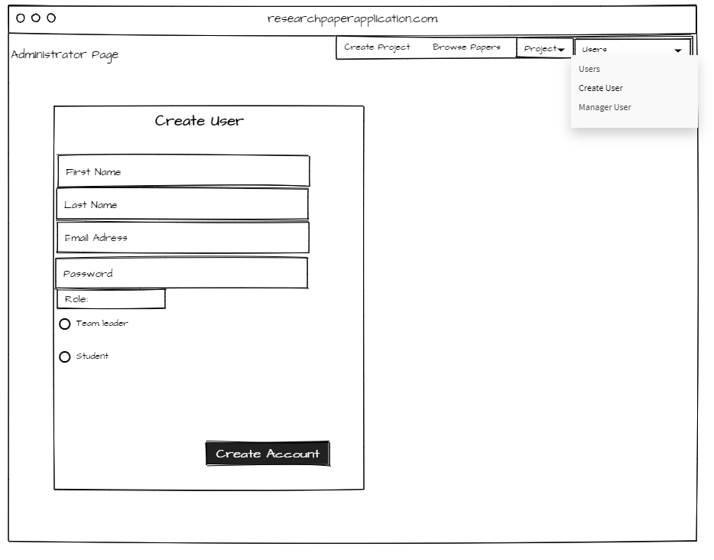

Figure Administrator: Manage Users

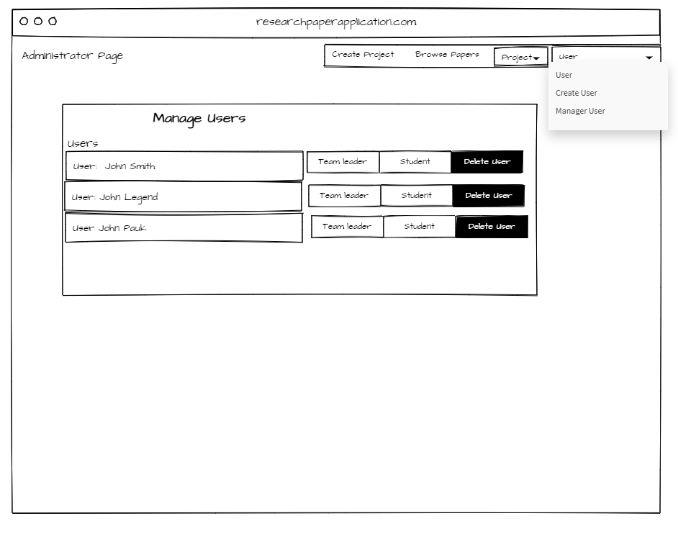

Figure Add user to Project and Delete project will also be available to Administrator.

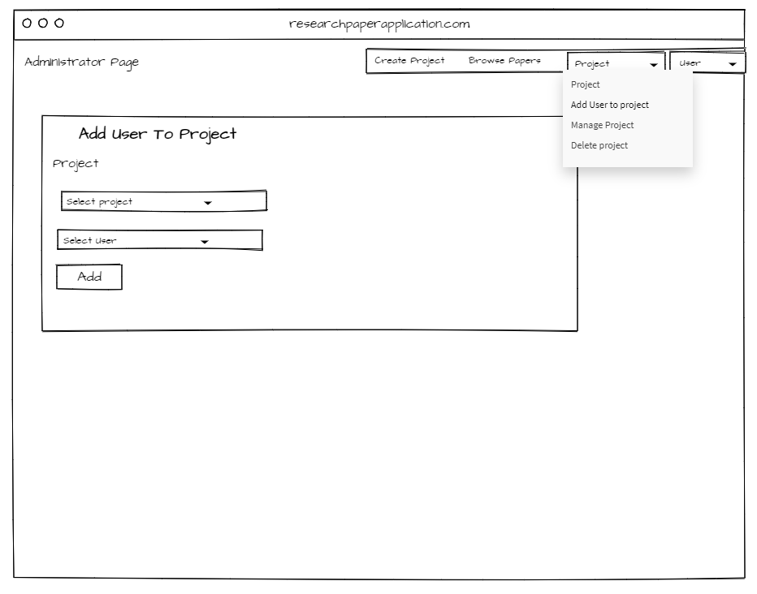

Figure Create Project

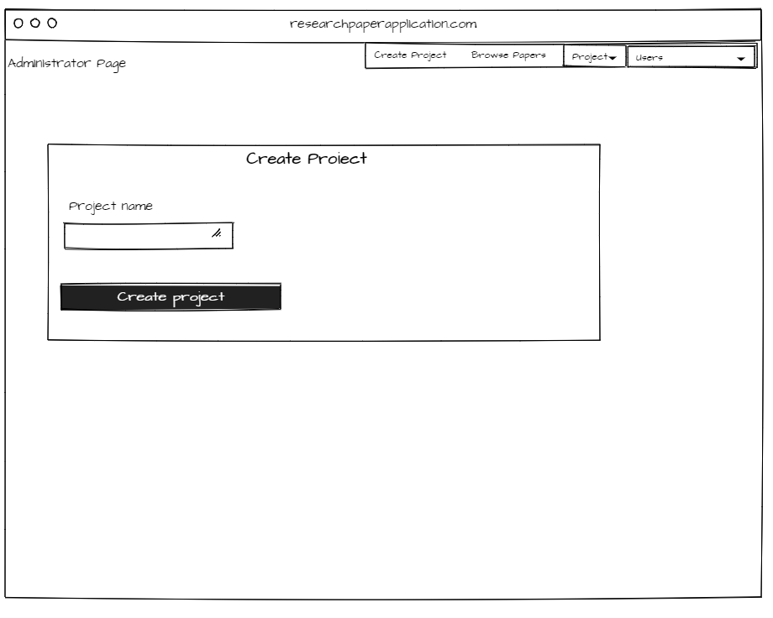

Figure Manage projects

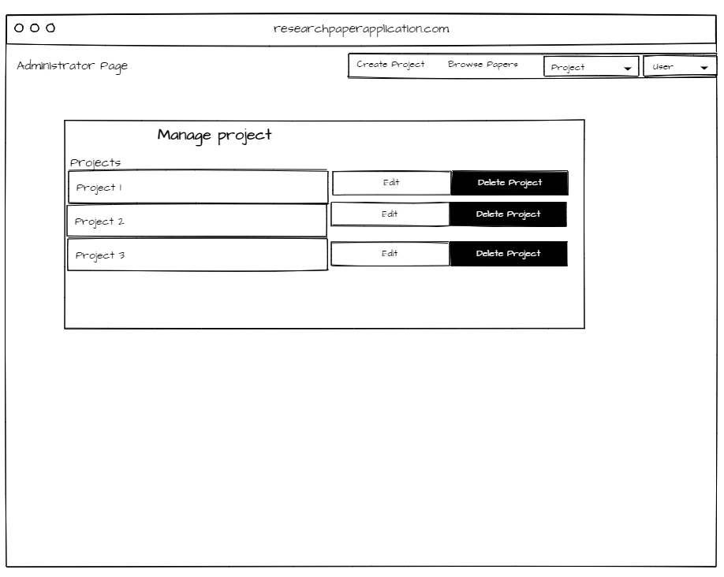

Figure Browse Projects

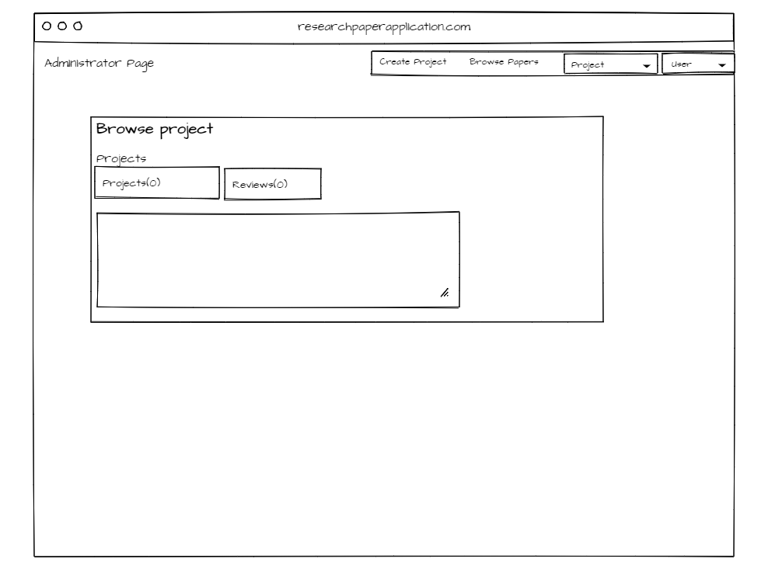

Figure Submit Paper to project

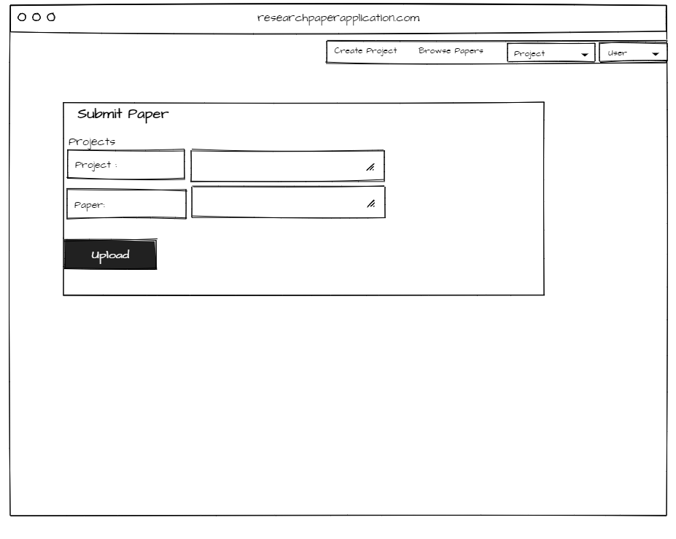

Figure Assign Paper to User

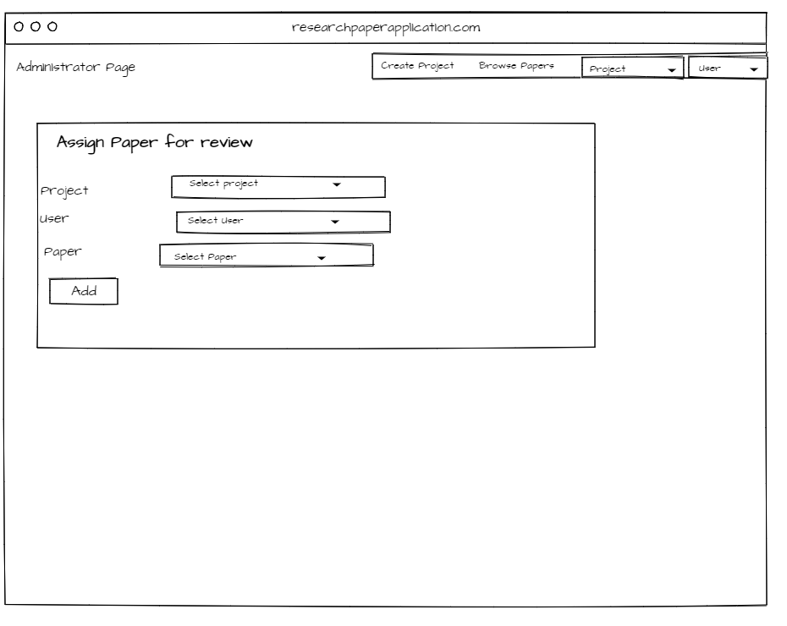

Figure Submit Review

